34.81: 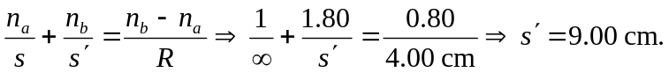 So the object distance for the far side of the ball is 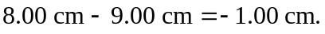
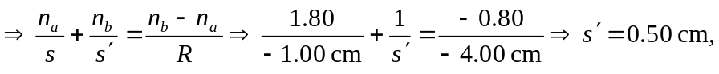 which is 4.50 cm from the center of the sphere.

